Rental Maintenance Activity (RMA)
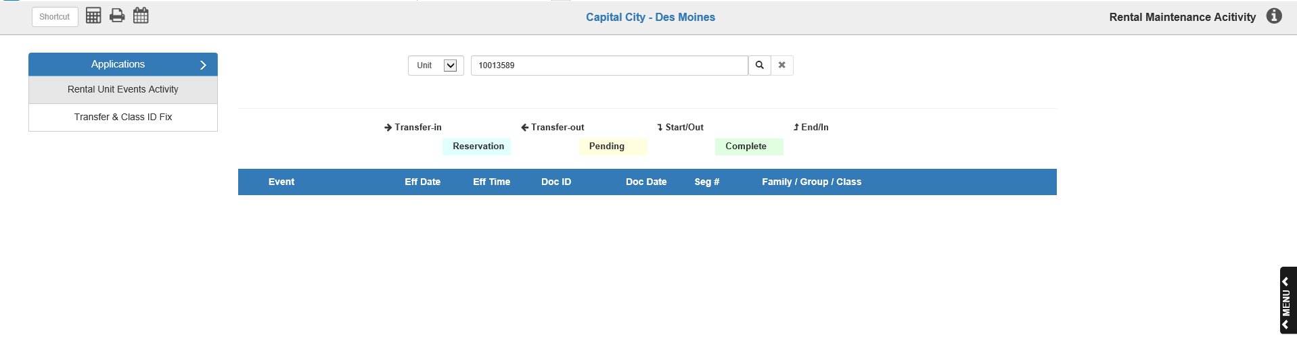
Rental Maintenance Activity (RMA) not only allows you to view a dealership’s rental activity by unit or class, but also to easily fix issues concerning Renal Unit records. To access the program, add the following to the end of your server URL: netview/re/RMA?curloc=loc1
Rental Unit Events Activity: This part of the application lets you view the activity history for either a particular Rental Unit or a particular Rental Class at a dealership.
Activity Descriptors: At the top of the screen are a set of descriptors which will help you easily determine what kind of activity has been performed on a unit or class and the current status of that activity.
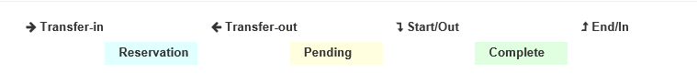
Transfer-in: If a Rental Unit has been transferred in to the dealership, this symbol and description will appear in the Event column.
Transfer-out: If a Rental Unit has been transferred out from the dealership, this symbol and description will appear in the Event column.
Start/Out: If a Rental Unit has been checked out and/or has started a rental period, this symbol and description will appear in the Event column.
End/In: If a Rental Unit has been checked in and/or has ended its rental period , this symbol and description will appear in the Event column.
Reservation: If a Rental Unit is on reservation, its entry in the activity list will appear this light blue color.
Pending: If the particular activity on a Rental Unit is pending completion, the activity entry will appear this pale yellow color.
Complete: If the particular activity on a Rental Unit is complete, the activity entry will appear this light green color.
Searching: To begin, select either “Unit” or “Class” from the drop-down menu at the top of the screen, depending on what activity you want to view, then type your search criteria in the Search field.
- If you select Unit, enter the Rental Unit ID in the Search field.
- If you select Class, enter the Class ID in the Search field.
Click the Search icon to the right of the field. The Unit or Class information will then populate the screen. The image below is an example of a Unit.
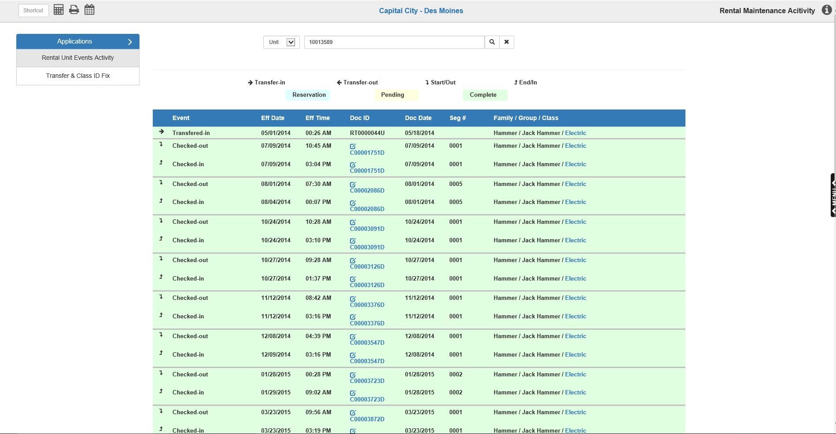
If you don’t know the entire Unit or Class ID, you can enter part of it in the Search field. The program will generate a list of possible results based on what you entered. Select the one you want from the entries presented or, if you don’t see it, use the search filters to narrow down the results. Below is an example of a Unit search.
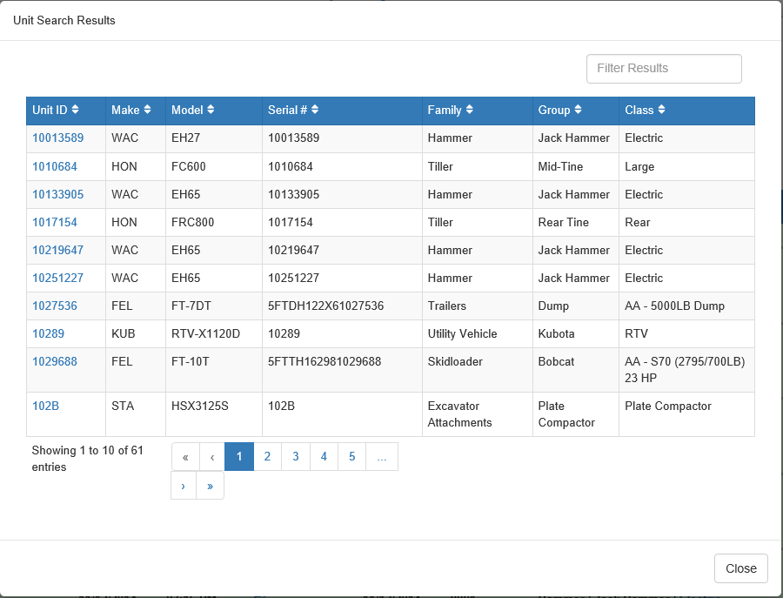

Unit Activity Display-Column Definitions: If you look up a Unit’s activity, the program will list the earliest activity performed on the Unit first, with the most recent activity appearing at the bottom of the listing.
Event: The Event column lists the activity performed, using the activity descriptors defined at the top of the screen.
Eff Date: The Effective Date column lists the date the activity went into effect on the unit.
Eff Time: The Effective Time column lists the time on the Effective Date that the activity went into effect on the unit.
Doc ID: The Document ID column shows the identifying number for the Rental Reservation or Contract associated with this Rental Unit activity. If the Doc ID is colored blue, then you can click on it to view the document. If it also appears with this icon next to it, you can click on the icon to edit the document in NetView Rental Reservations and Contracts (RENT).
Doc Date: The Document Date column shows the date of the associated Rental Reservation or Contract listed in the Doc ID column.
Seg #: The Segment Number column shows the number of the document segment where this activity is recorded, if applicable.
Family/Group/Class: This column shows the unit’s family, group, and class.

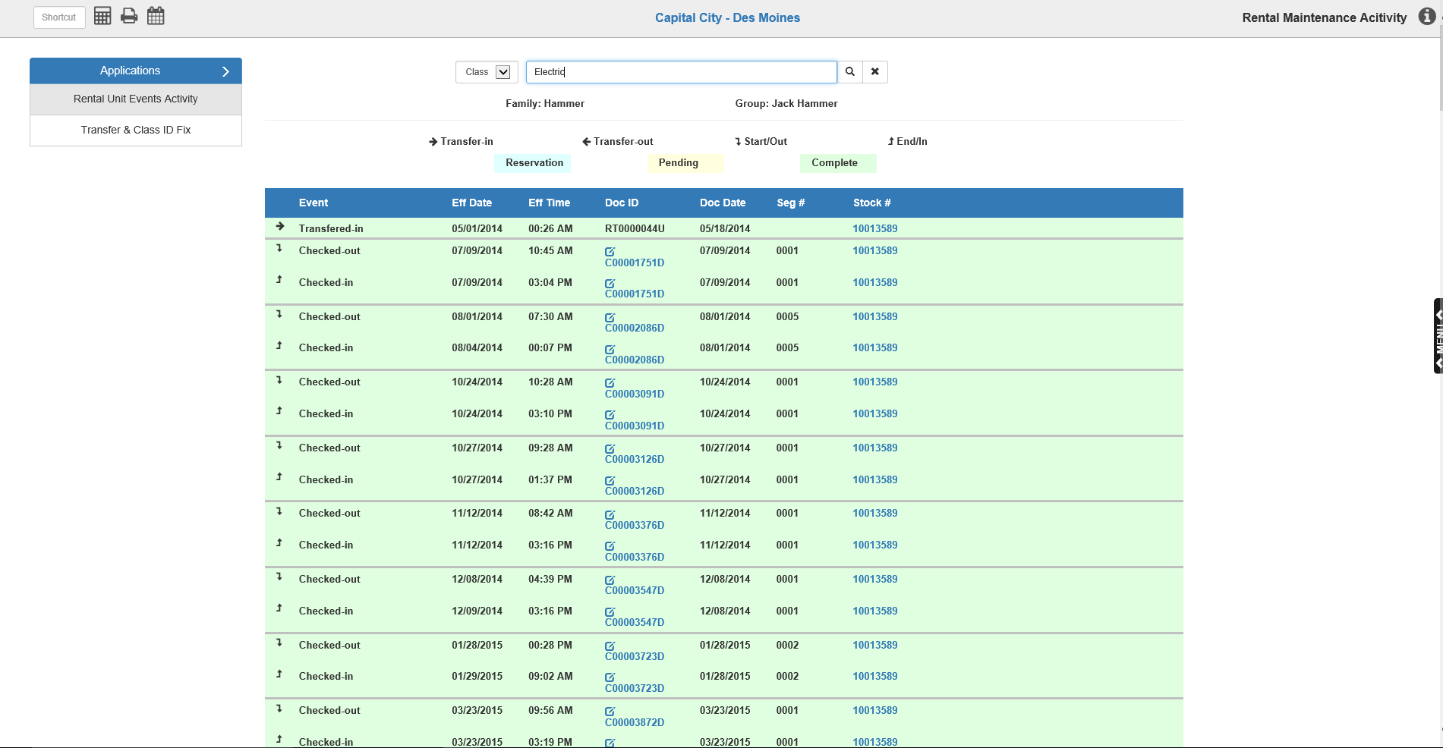
Class Activity Display-Column Definitions: If you look up a Class’s activity, the program will list the activity first in ascending order of Rental Units, then by the date of activity. In other words, the first entry on the list will be the earliest activity performed on the Rental Unit with the “smallest” stock number.
Event: The Event column lists the activity performed, using the activity descriptors defined at the top of the screen.
Eff Date: The Effective Date column lists the date the activity went into effect on the unit.
Eff Time: The Effective Time column lists the time on the Effective Date that the activity went into effect on the unit.
Doc ID: The Document ID column shows the identifying number for the Rental Reservation or Contract associated with this Rental Unit activity. If the Doc ID is colored blue, then you can click on it to view the document. If it also appears with this icon next to it, you can click on the icon to edit the document in NetView Rental Reservations and Contracts (RENT).
Doc Date: The Document Date column shows the date of the associated Rental Reservation or Contract listed in the Doc ID column.
Seg #: The Segment Number column shows the number of the document segment where this activity is recorded, if applicable.
Stock #: The Stock Number column shows the Unit ID of the Rental Unit the activity is performed on.

Switching between Unit and Class Activity: You may notice that in the Unit activity display, the unit’s class is colored blue, likewise with the unit’s stock number in the Class activity display. This is to allow you to use the Unit and Class IDs to switch between the two activity displays.
To switch from Unit activity to Class activity, click the blue Unit Class in the Family/Group/Class column.
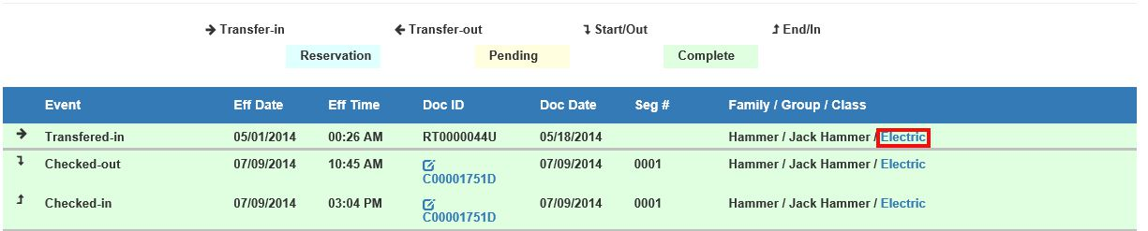
To switch from Class activity to Unit activity, click the blue Unit Stock Number in the Stock # column.
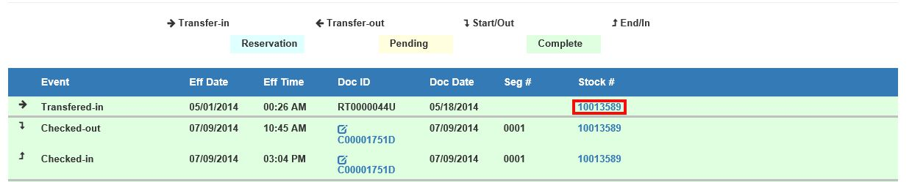

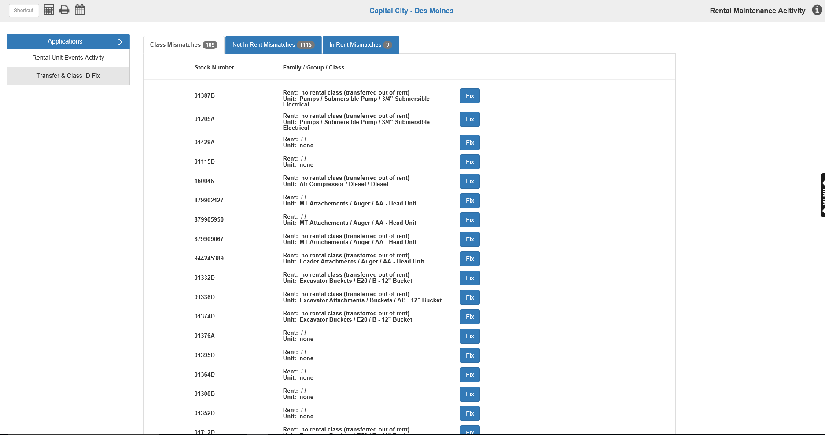
Transfer & Class ID Fix: This part of the application lets you apply fast fixes to errors in the Rental records.
Automatic Transfer Validation: When you first open the section, the following box will appear:
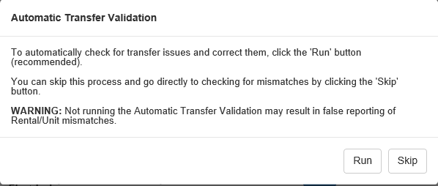
This feature allows you to automatically check for and correct transfer issues. To run the Automatic Transfer Validation, click Run. To manually check for and fix mismatches, click Skip. WARNING: Not running the feature may result in false reporting of mismatches, so we recommend you run the feature.

If you hit “Skip,” the system will compile all errors and display them on the main screen for you.

Class Mismatches: This tab displays a list of units that have a different class in Unit Inquiry (UI) than what is in Rental. Each unit in this tab is listed by stock number, with its family/group/class in the next column.
To change the unit’s class information to match the Rental record, click Fix next to the entry. If the fix is successful, you will receive a success message and the entry will disappear from the tab.

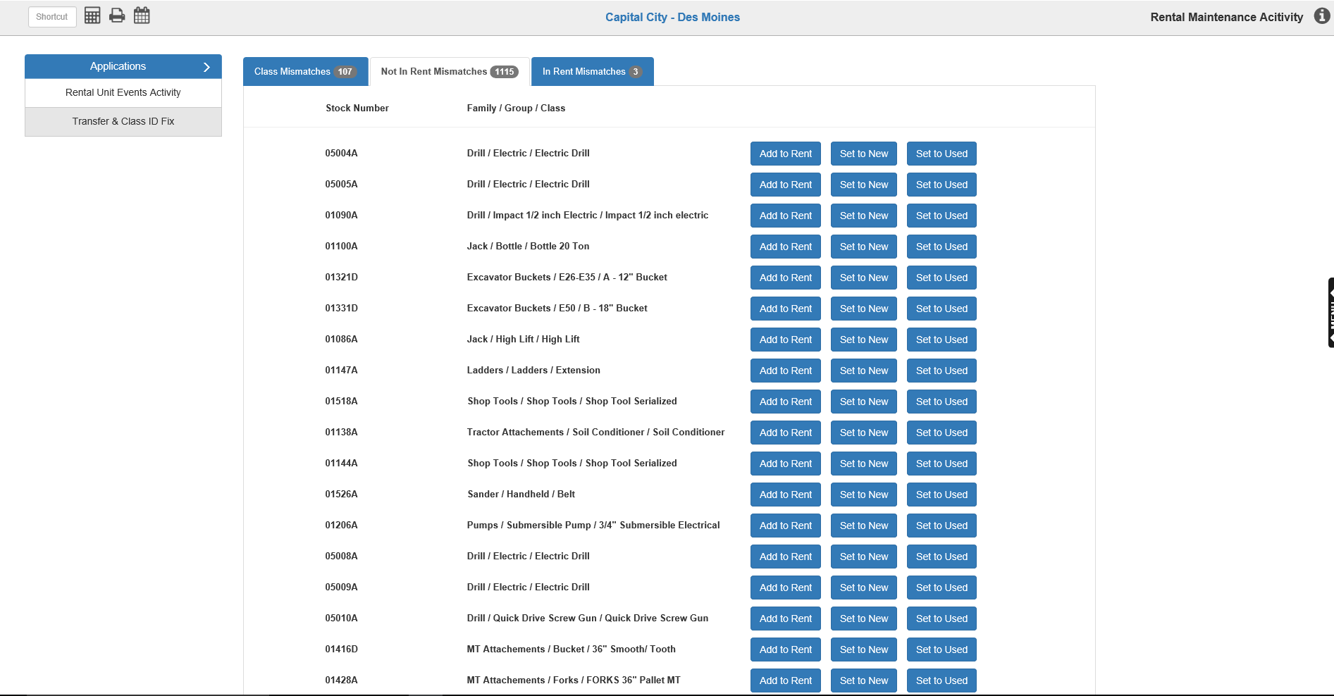
Not In Rent Mismatches: This tab shows errors where a Unit is not in Rental, but its status is still set to Rent. Each unit is recorded by its stock number, along with its family/group/class. You have three options to fix this error.
Add to Rent: Click “Add to Rent” to add a transfer-in to Rental using the unit’s class information. The following window will open:
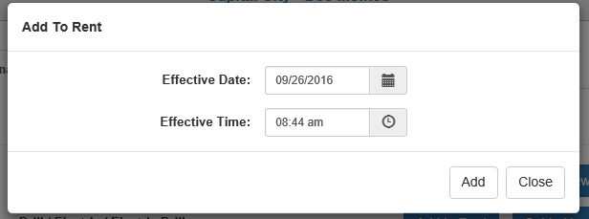
Enter the Effective Date and Time for the transfer-in, or select them using the calendar and clock icons, respectively. Click Add to add the unit to Rental. If the transfer goes through, you will receive a success message and the unit will disappear from the tab.
Set to New: Click “Set to New” to change the unit’s status to New. If the fix succeeds, you will receive a success message and the unit will disappear from the tab.
Set to Used: Click “Set to Used” to change the unit’s status to Used. If the fix succeeds, you will receive a success message and the unit will disappear from the tab.

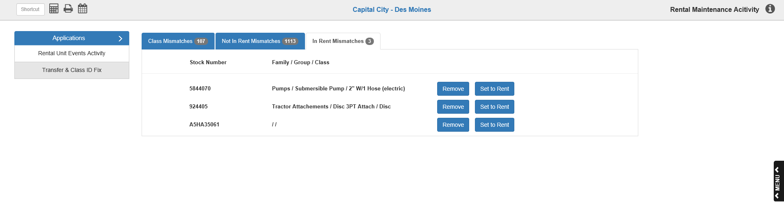
In Rent Mismatches: This tab shows units that are in Rental, but their status is set to something other than Rent. Each unit is listed by stock number, along with its family/group/class. You have two fix options available in this tab.
Remove: Click “Remove” to remove the unit from Rental by adding a transfer-out of the Unit in Rental. The following window will appear:
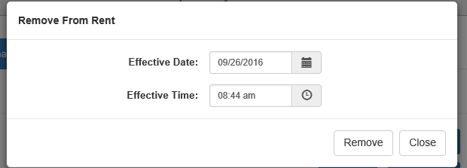
Enter the Effective Date and Time for the transfer, or select them using the calendar and clock icons, respectively. Click Remove to complete the transfer. If the process succeeds, you will receive a success message and the unit will disappear from the tab.
Set to Rent: Click “Set to Rent” to change the unit’s class to Rental and add the Rental class to the unit’s information. If the fix succeeds, you will receive a success message and the unit will disappear from the tab.

